Packet Capture and Analysis Research
Owen Boisse

Data Packet Capture
https://www.thousandeyes.com/learning/glossary/packet-capture
https://www.varonis.com/blog/packet-capture#:~:text=What%20is%20Packet%20Capture%3F,-%C3%97&text=Packet%20Capture%20refers%20to%20the,pcap%20format

What is Network Packet Capturing?
Capturing is the process for intercepting data packets travelling through a network.
After capture, it can be analysed and used to help determine network problems such as security threats and any lost packets.

After a data breach, these packets can provide forensic clues to help with investigations.

Packet Capture can also be a threat as they can be used to steal important information in transit, and capturing packets can be accomplished without leaving any trace.

Types of packet capture:
We can choose to capture entire packets or only specific sections of it such as just the header through filtering in order to save time, space, and resources.

How does packet capturing work?
Packeting capturing involves creating copies of data packets passing through a specific point in a network.

This can be done from a router or a switch or any computer device.

Own machine:
Easiest method, however network interfaces only pay attention to traffic destined for them.
In order to get more network traffic, the interface needs to be put in promiscuous mode or monitor mode. This method makes packet capture limited, since you will only see traffic on the local switch port your machine is connected to on a wired network.

Router or switch:
Port mirroring, port monitoring allow network traffic to be copied and sent to a specific port, in order to export them to a dedicated monitoring system. Firewalls and WAPs also have packet capture methods.

Packets are captured going through a device in the network

Analysis - Protocols:

In order to break down a packet, we need to know the contents and what they are used for.

TCP and IP:
Internet Protocol (IP)
- Used for sending data across the internet or a smaller network, between source and destination addresses.
- Defines how applications and devices send packets.
- TCP/IP protocol stack is used to achieve this.
- IP obtains the IP address.

Transport Control Protocol (TCP)
- Responsible for data delivery once an IP address is found.
- Establishes a connection between the source and destination devices, and makes sure it stays active, until it ends.
- Breaks down the data into packets.
- High level protocol that transmit data use TCP, such as FTP, SSH, IMAP, POP, SMTP, and HTTP.
- UDP is an alternative but does not have packet sequencing or errors, however it is less expensive

TCP/IP model:
- Default method of data communication across the Internet.
- Divides tasks into layers to keep processes standardised.

Four layers:
- Data Link Layer:
  - Defines how data should be sent, the physical process of exchanging data
- Internet Layer:
Sending packetsffrom a network and ensures they get to their destination.
- Transport Layer:
  - Establishes data connection between sender and receiver.
  - Divides data into packets and sequences them.
  - Determines where packets should be sent, at what rate etc.
- Application Layer
  - Level users interact with.
  - Combines sessions, presentation and application layers of the OSI model.

Data packets sent over TCP/IP are not private, and can be intercepted.

OSI Model:
An alternative to TCP/IP is the Open Systems Interconnection (OSI) model, which consists of seven layers instead of TCP/IPs four.

TCP/IP vs OSI:
TCP/IP:
- Solves specific communication problems
- Uses specific, standard protocols
- Most applications use all 4 layers

OSI Model:
- Generic, protocol-independent
- Can describe all forms of network communication
- Simple applications only use the 1st,2nd, and 3rd layers sine they are the only ones required for data communication.
https://www.imperva.com/learn/application-security/osi-model/

OSI’s Seven Layers:
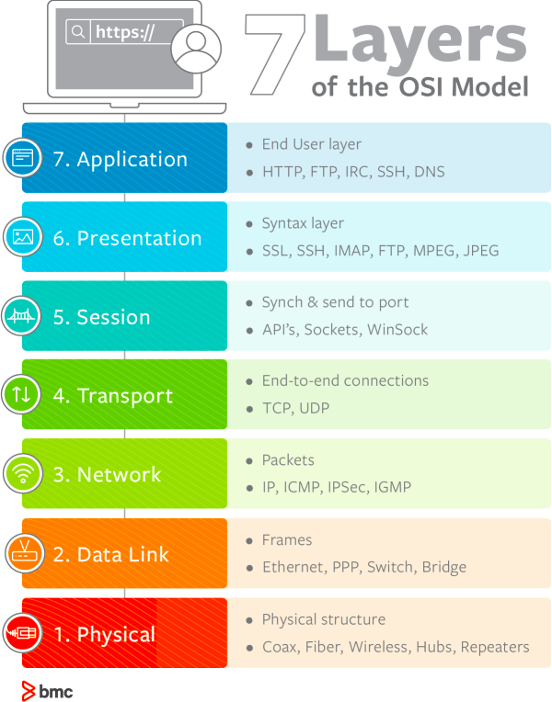
(Source: https://www.bmc.com/blogs/osi-model-7-layers/)

1 Physical:
- Communication of raw data over a physical medium.

2 Data Link
- Data transmission between network nodes
- Connections between connected devices
- Data from physical layer packaged into frames, containing protocols to send them between nodes

3 Network
- Organises and transmits data between multiple networks.
- Routes data through the optimum path.
- Addressing for packets to distinguish source and destination networks.
- Divides into packets, and put back together at receiving end
- IPv4, IPV6

4 Transport
- Ensures reliable delivery of packets
- TCP, UDP

5 Session
- Manages sessions between servers to coordinate communication,
- Responsible for starting, ending, authentication etc, of communication.

6 Presentation
- Converts data formats between applications and networks
  - Data conversion
  - Compression
  - Encryption

7 Application
- Layer that the user interacts with

Contents of a IP packet header:
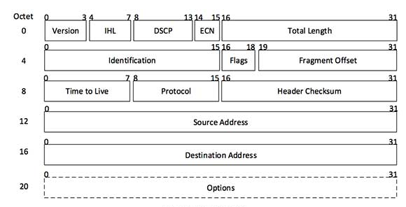
- Version - version number of Internet Protocol being used such as IPv4 or 6
- IHL - Internet Header Length - length of the entire IP header
- DSCP - Differentiated Services Code Point - type of service
- ECN - Explicit Congestion Notification; it carries information about the congestion seen in the route
- Total Length - length of the whole IP packet, i.e. header + payload
- Identification - if IP packet is fragmented during the transmission, all the fragments contain some identification number to identify the original packet they belong to
- Flags - required by network resources, if IP packet is too large to handle, these “flags” tells if they can be fragmented or not.
- Fragment offset - the exact position of the fragment in the original IP packet
- Time to Live - In order to avoid endless looping, packets have a TTL value, this tells the network how many routers, known as hops, this packet can cross decrementing the value until the packet is discarded.
- Protocol - tells the Network layer at the destination host, to which protocol this packet belongs to, e.g. protocol number of ICMP is 1, TCP = 6, and UDP = 17.
- Header Checksum - checksum value of entire header in order to check if the packet is received without errors
- Source address - 32-bit address of the source of the packet
- Destination address - 32-bit address of the destination of the packet
- Options - optional field used if value of IHL is larger than 5. Options contains values for options such as security, record route, time stamp, etc.

Contents of a TCP Header:
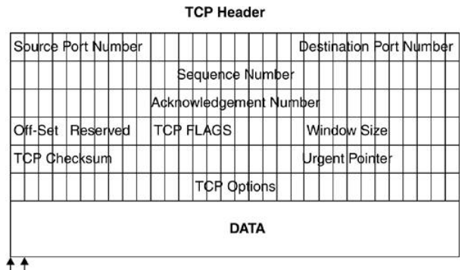
Source: (http://books.gigatux.nl/mirror/securitytools/ddu/ch06lev1sec3.html)

IP header establishes connection with correct device, and the the TCP header is used to establish a TCP session as to send the packets to the right ports on the established device, 20 Bytes long
- Source port - 16 bits
- Destination port - 16 bits
  - These port numbers identify which ports the packets neede ot be sent to.
- Sequence number - used to reassemble the packets in the correct order at the receiving end.
- Acknowledgement number - 32 bits - verification that it is coming from the correct device.
- Offset - 4 bits - number of 320bit lines there are in the TCP header
- Reserved - 6 bits - same as IP header, these are reversed in case needed in the future
- TCP flags - 6 bit -controls how the packet is handled
- Window size - amount of bits the sender is able to receive
- TCP checksum
- Urgent pointer
- TCP options - additional information - padded out to 32 bits

TCP Flags:
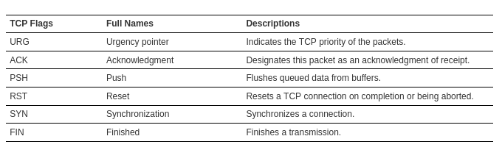
(Source: http://books.gigatux.nl/mirror/securitytools/ddu/ch06lev1sec3.html)

Apart from the header, packets also contain a payload which consists of the actual data being sent.
The process of analysing the payload is called Deep Packet Inspection (DP) and can identify malicious traffic and malware etc. inside, however we will aim to filter the payload out due to the considerable size of them and any privacy issues associated with it.

Problems to solve:
- Packet capture is easy for incoming packets to local machines by using python libraries such as socket, much harder to actively collect packets from a network.
- There are a variety of ways to analyse a data packet so will need to decide on the scope of our program.
- Need to choose which library to use for capturing and analysis

Potential Python Libraries:
Socket:
- Sockets are used to send messages across a network.
- Provides access to a socket interface, which is transliteration of the Unix system call and library interface for sockets to Python’s object-oriented style.
- Need to break down received packets manually requiring knowledge of packet structure.

Scapy:
- External library
- Enables the user to send, sniff and dissect, and make network packages.
- Allows us to probe or scan networks.
- Suitable for a variety of protocols
- Scanning, tracerouting, probing, unit tests, network discovery

Pyshark:
- External library
- Python wrapper for tshark (wireshark command-line utility)

